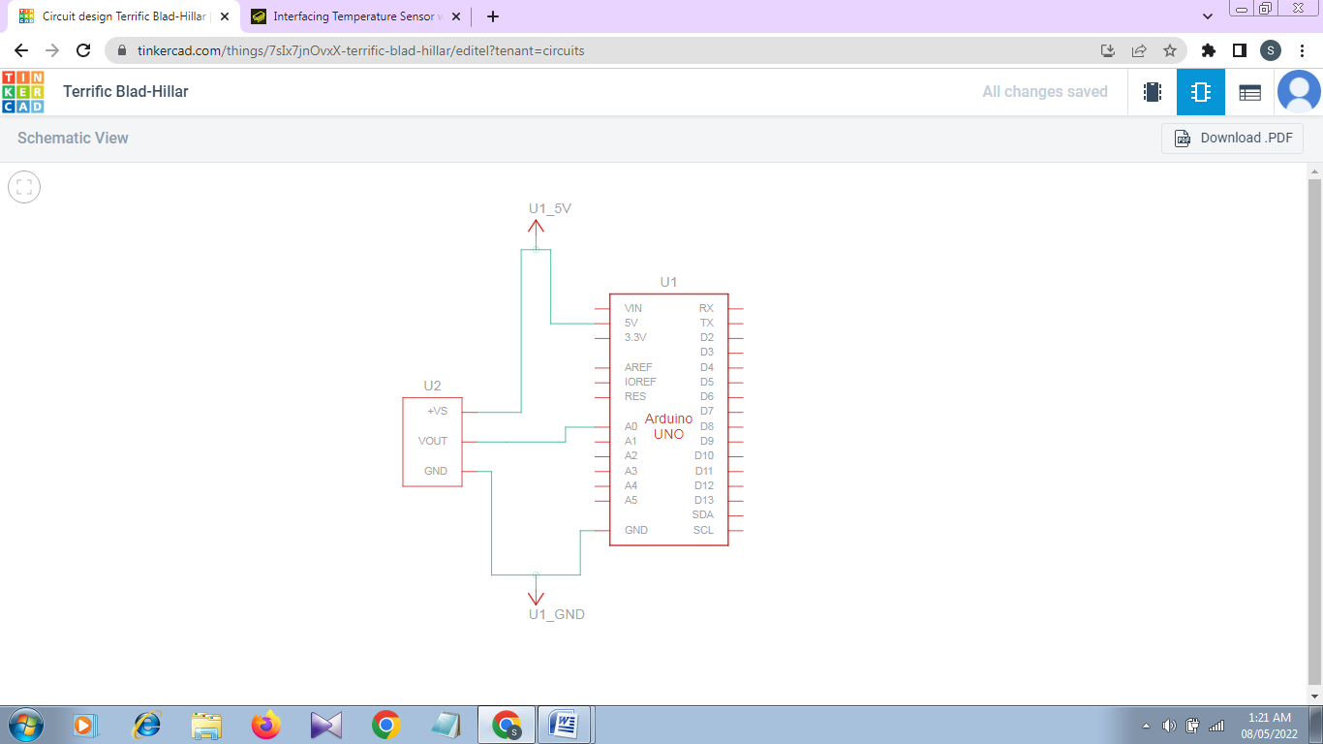**Schematic View:**

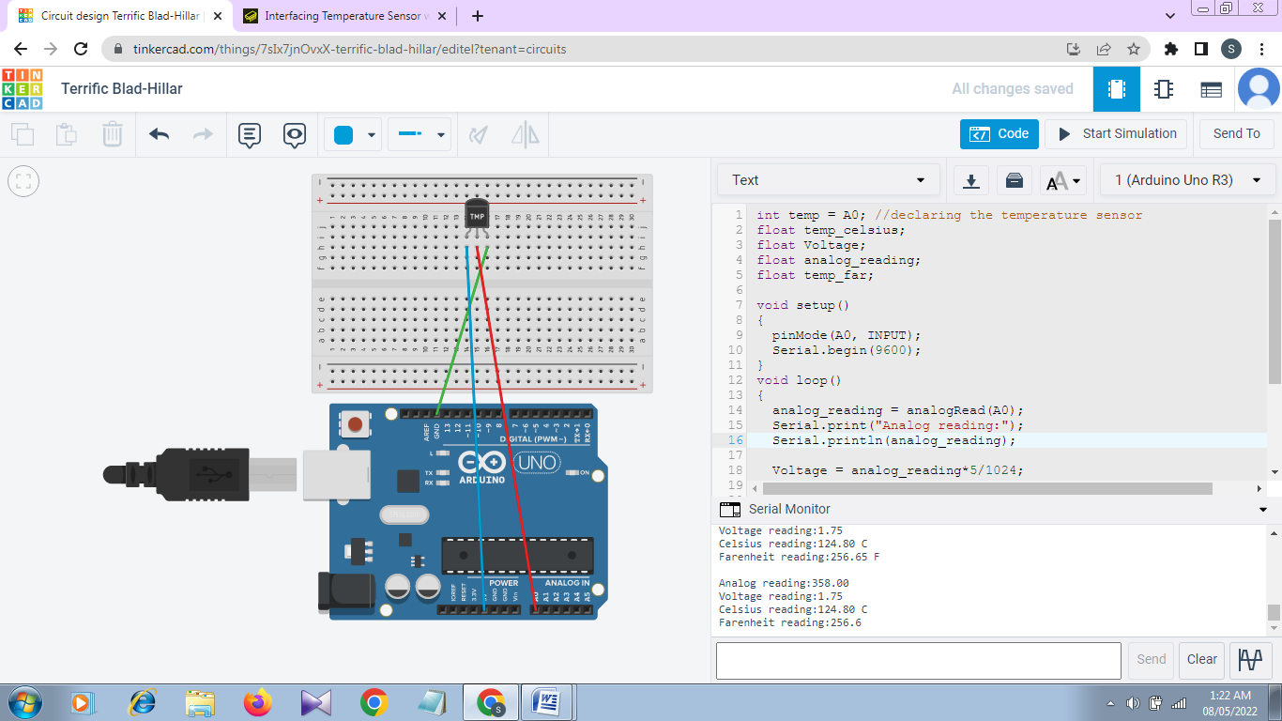**Circuit**

**Code:**

int temp = A0; //declaring the temperature sensor

float temp_celsius;

float Voltage;

float analog_reading;

float temp_far;

void setup()

{

pinMode(A0, INPUT);

Serial.begin(9600);

}

void loop()

{

analog_reading = analogRead(A0);

Serial.print("Analog reading:");

Serial.println(analog_reading);

Voltage = analog_reading*5/1024;

Serial.print("Voltage reading:");

Serial.println(Voltage);

temp_celsius = 100* (Voltage - 0.5) ;

Serial.println("Celsius reading:" + String(temp_celsius) + (" C"));

temp_far = (temp_celsius * 9/5) + 32 ;

Serial.println("Farenheit reading:" + String(temp_far) + (" F\n"));

}